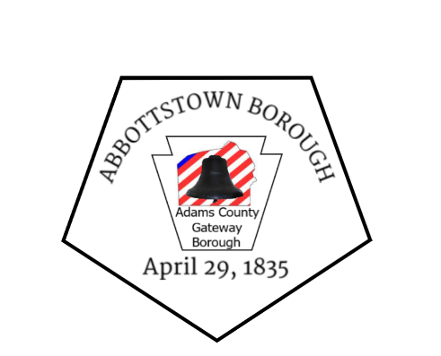 Abbottstown Borough 241 High Street Abbottstown, PA 17301 717-259-0965 *** fax 717-259-6213 E-mail abbottstown@comcast.net
Website www.adamscounty.us/Munic

February 21, 2019

To: All Media Outlets, Constituents of Abbottstown and East Berlin Boroughs, Cumberland and Straban Townships

From: David W. Bolton, Municipal Administrator, Abbottstown Borough

Re: Ecycling Events for 2019

--------------------------------------------------------------------------------------------------------------------

FOR IMMEDIATE RELEASE

The townships of Cumberland and Straban, partnered with the boroughs of Abbottstown and East Berlin, have announced their 2019 E-cycling Collection Events. All four events are open to constituents of these four municipalities as part of their paid solid waste collection service.

Events will be held 8a-10a: March 16th Emergency Services Bldg, 230 Greenamyer Lane
June 8th Municipal Bldg., 1370 Fairfield Road, Gettysburg
Sept. 14th Abbottstown Rec Park, 241 High St. Abbottstown
Dec. 7th East Berlin Boro Park, 523 North Ave. East Berlin

All electronic devices are accepted with Photo ID and a receipt of your Waste Connections bill.
Any inquiries can be directed to the municipal offices listed above.

--------------------------------------------------------------------------------------------------------------------

Gratefully,

David W. Bolton, MBA, CBO
Municipal Administrator
Secretary/Treasurer
Open Records Officer
Abbottstown Borough

